Answer
L 11 : probabilities (Part II)
Using Tree Diagram to list out the possible outcomes

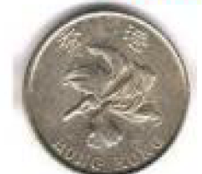
When we toss 1 coin, the possible outcomes are ‘Head’ and ‘Tail’ only.

When we toss 2 coins, there would be more possible outcomes.
(Different combination of ‘Head’ and “Tail’.)

In this case, we would use a Tree diagram to list out all the possible outcomes.
‘H’ stands for ‘Head’ while ‘T’ stands for ‘Tail’

From the tree diagram, there are 4 possible outcomes, when we toss 2 coins.
Example : $P\left(getting exactly 1 head and 1 tail\right)=\frac{2}{4}=\frac{1}{2}$

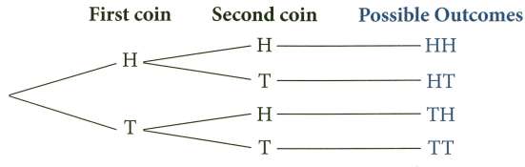

1. Candy tosses a fair coin twice.
(a) List all the possible outcomes by a tree diagram.
(b) Find the probability that Candy gets two tails.

(a)
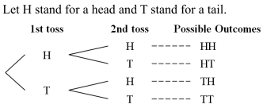
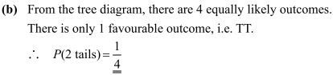

2. There are $2$ true-or-false questions in a quiz. The correct answers to the two questions are ‘false’ and ‘true’ respectively. Ben answers the $2$ questions by wild guessing.
(a) List all the possible outcomes by a tree diagram.
(b) Find the probability that he gets only one answer correct.

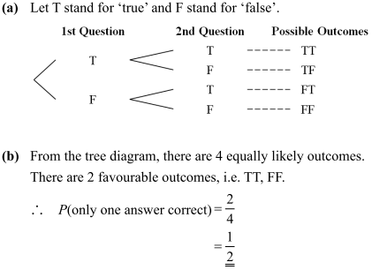

3. Mr. Chan has two children.
(a) List all the possible outcome by a tree diagram.
(b) Find the probabilities that he has
(i) two daughters
(ii) $1$ daughter only

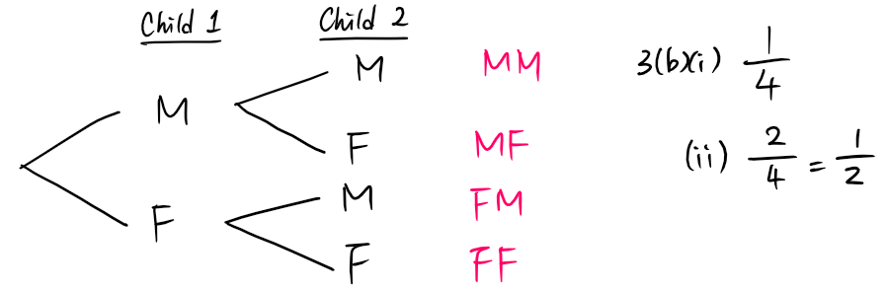

4. There are two questions in a quiz. The first one is a true-or-false question and the answer is ‘true’. The second one is a multiple-choice question which offers $4$ choices: $A, B, C, D$ and the answer is ‘$C$’. If Wallace chooses his answers at random,
(a) List all the possible outcomes by a tree diagram.
(b) find the probabilities that he gets
(i) both answers correct,
(ii) both answers wrong.

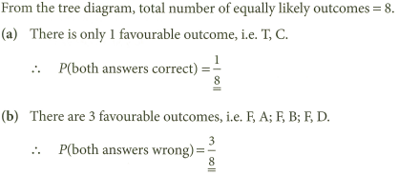
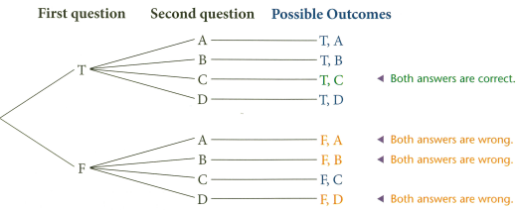
(a)

(b)(i)

(b)(ii)

5. A coin is tossed and a dice in the shape of a regular tetrahedron is thrown. The numbers $1, 2, 3$ and $4$ are marked near the vertices of the dice. The outcome of throwing this dice is the number near to top of the dice.
(a) List all the possible outcomes by a tree diagram.
(b) Find the probabilities of getting
(i) a head and the number ‘3’,
(ii) a tail and a prime number.

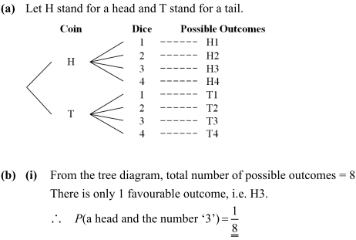
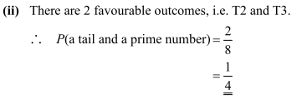

Using Tabulation to list out the possible outcome

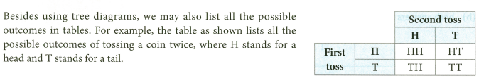

6. Two dice are thrown.
(a) List all the possible outcomes in a table.
(b) Find the probabilities that
(i) the difference of the $2$ numbers is equal to $3$,
(ii) the sum of the $2$ numbers is a multiple of 3.

 |  | Second outcome
First Outcome | 1
 | 2
 | 3

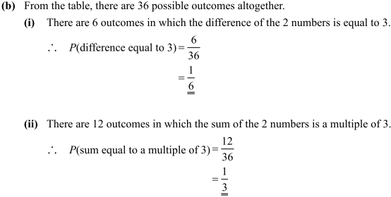

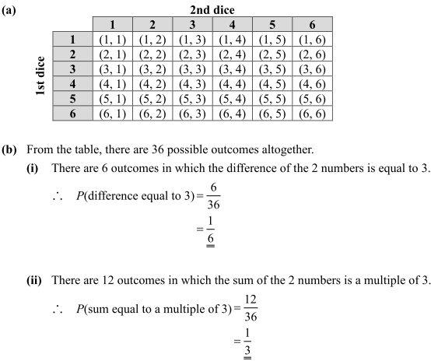

7. Edith selects two numbers at random from $1, 2$ and $4$ to form a $2$-digit number. These numbers can be selected more than once.
(a) Use a table to list all the possible $2$-digit numbers.
(b) Find the probabilities that the $2$-digit number formed is
(i) a multiple of $3$,
(ii) divisible by $4$.

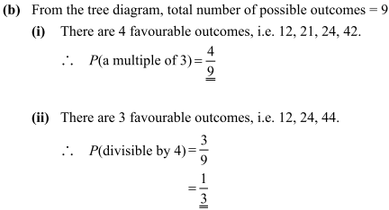
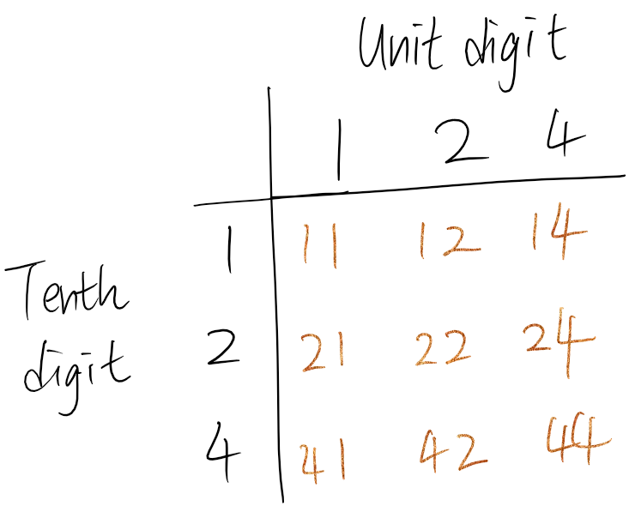
(a)

8. A shop offers a gift-wrapping service as shown below.

Sara has bought a gift from the shop. She needs a piece of wrapping paper and a ribbon for the wrappings.
(a) With the help of a table, list all the possible outcomes of the wrapping cost of Sara’s gift.
(b) Find the probability that she pays more than $\$15$ for the wrappings.

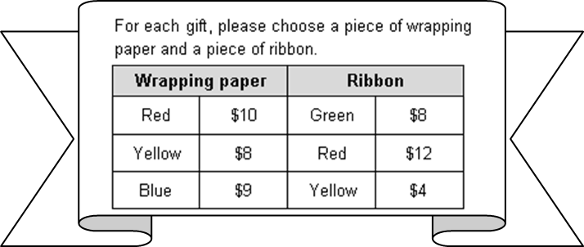

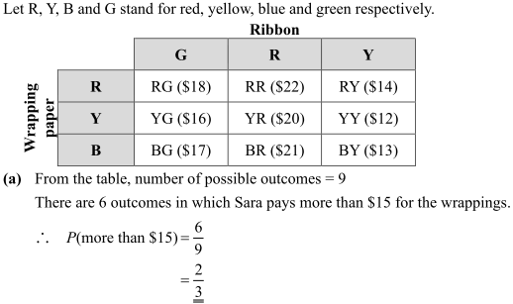
(a)
(b)

9. A pair of white socks, a pair of black socks and a pair of red socks are put in a drawer. Jason draws
$2$ socks one by one from the drawer at random without replacement.
(a) Use a table to list all the possible outcomes.
(b) Find the probabilities that
(i) the $2$ socks are of the same colour,
(ii) at least one of the socks is black in colour.

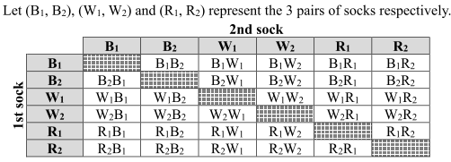
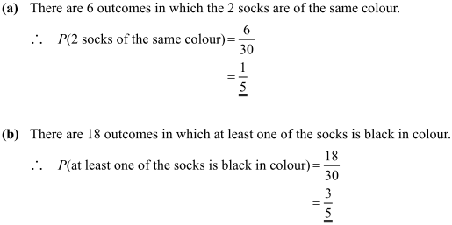
(b)(i)
(b)(ii)
(a)

10. A bag contains $1$ green marble, $1$ black marble and $2$ red marbles. Two marbles are drawn successively from the bag at random.
(a) List all the possible outcomes in a table.
(Use $G$ to denote a green marble, $B$ to denote a black marble and $R$ to denote a red marble.)
(b) Find the probability that the two marbles drawn are of different colours.

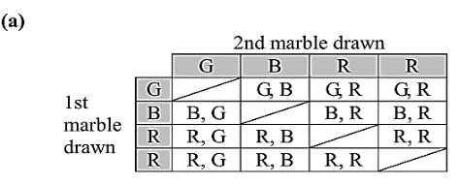
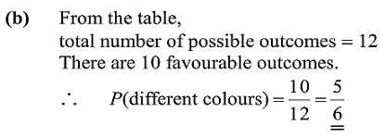

11. There are $3$ men and $2$ women in a tennis class. If $2$persons are chosen at random to play a match,
(a) Use a table to list all the possible outcomes.
(b) find the probabilities that the $2$ persons are
(i) $2$ men,
(ii) $1$ man and $1$ woman.

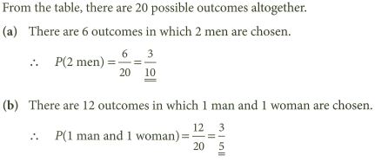
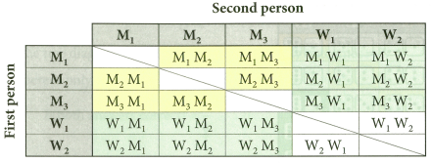

Application Questions

12. Two numbers are chosen at random one by one from the numbers $‘3, 7$ and $8’$. A number is formed by placing the first drawn number as the tens digit and the second drawn number as the unit digit.
What is the probability that the number formed is an odd number?

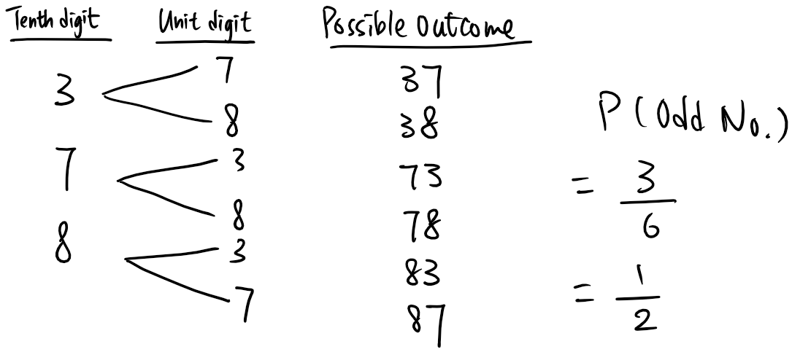

13. Celine has a $\$10$ note, a $\$20$ note, a $\$50$ note and a $\$100$ note in her purse. If she takes out $2$ notes randomly from her purse, find the probability that she gets at least $\$70$.

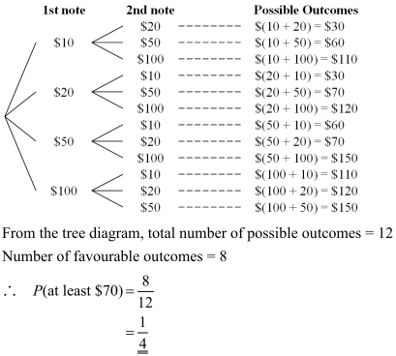

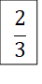

14. There are four gateways $A, B, C$ and $D$ in an exhibition hall. Josephine enters through one of the four gateways at random and leaves through on of the other three gateways at random. Find the probability that Josephine didn’t pass through gateway $D$.

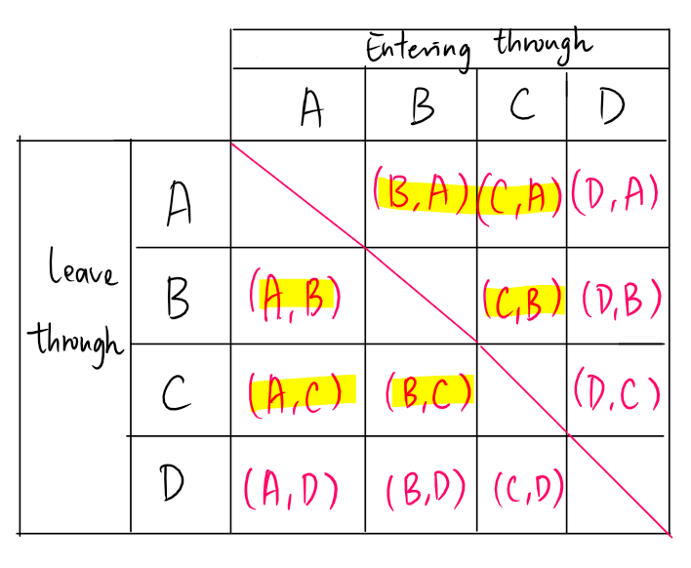
- $P\left(didn^{'}t pass D\right)=\frac{6}{12}$
$$=\frac{1}{2}$$

15. Rosa arranges the numbers ‘$6$’, ‘$5$’ and ‘$1$’ randomly to form a $3$-digit number. Each number can be used once only. Find the probability that the number formed is a multiple of $5$.

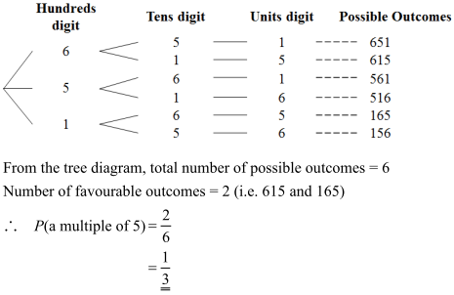

16. In bag $A$, there are $1$ green ball and $2$ yellow balls and $1$ red ball. In bag $B$, there are $2$ green balls and $1$ yellow ball. Ball $X$ is randomly drawn from bag $A$ and put into bag $B$.
(a) Find the probability that ball $X$ is not yellow.
(b) After ball $X$ is put into bag $B$, a ball $Y$ randomly drawn from bag $B$. Note that ball $X$and ball $Y$ may refer to the same ball.
(i) If ball $X$ is yellow, find the probability that ball $Y$ is red.
(ii) Find the probability that ball $Y$ is red.

